Project Simulation
Cognizant Business Model

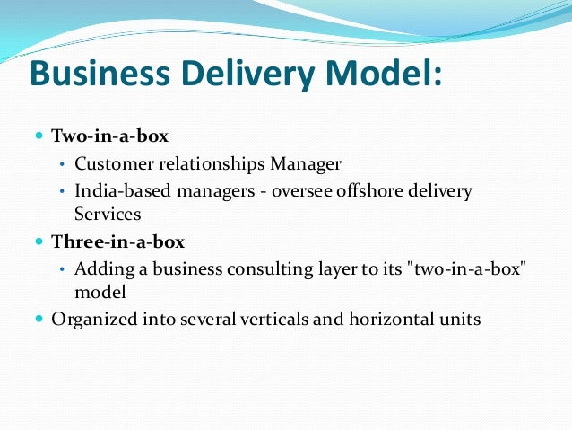
Consultant

Roles

Roles and Responsibilities of the PM:
- PM Should organize a call with the client and the team members to discuss the project requirements.
- Will introduce the team members to the client during the call
- After the call the PM will send the MOM of the call
- Follow up the team lead for the SRS, Design document and database schema.
- Update the client with the status of the project regularly
- Responsible for the client’s approval of SRS, Design document and database schema.

Roles and Responsibilities of the Team Lead
- Interacts with the PM for any clarifications
- Delegates the tasks to the team members
- Follow up the team members to complete the task on time
- Shares the completed SRS and design document to the Project Manager
- Responsible for the changes suggested by the project manager
Roles and Responsibilities of the Developers
- Should ask relevant questions to the client for proper understanding of the project requirements
- Note the requirements properly
- Should prepare the SRS and Design document and deliver it to the team lead on time. (Design can be a screen short from a relevant web site)
- Communicate to your TL for additional time if you need any
Roles and Responsibilities of the Client:
- The client interviews all the project team members to understand the skill set and experience before assigning the project.
- Document the skills and experience of the project members and share it with the Lead Client
- The client should produce the basic requirements of the project. (Two-page website – 1 – Login, 2- Registration page.)
- Set deadline for the delivery of the project.
- Follow up with the PM for the timely delivery of the project
- Approve the project on receiving the SRS, Design document and database schema.
- Client can suggest changes in the documents received

Process
Step1.
The PM should send an invitation to all the project members including the client. The invite should have a proper agenda for the meeting.
Step2.
The project team gets on a call along with the client to discuss the requirements.
Step3.
The PM sends a MOM to all the invitees after the call
Step4.
The PM sends a kick start mail to the Team Lead to work on the SRS and Design document stating the requirements discussed on the client’s call.
Step5.
The TL replies to PM’s mail and sends mails to the team members’ delectating the tasks.
Step6.
The team members complete their task and share the work with the TL.
Step7.
The TL collates the documents and sends them to the PM.
Step8.
The PM shares the documents with the client for approval.
Step9.
The client verifies and approves the documents.
Step10.
The PM thanks the client for approval and communicates to the team to start the project.

Note:
- All communication should be professional and through mail and calls.
- No informal communication is entertained during the activity.
- Everyone should be active in performing their roles.

Sample Design of Login Page

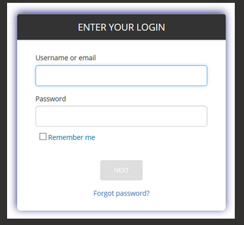

Design of a Registration Page
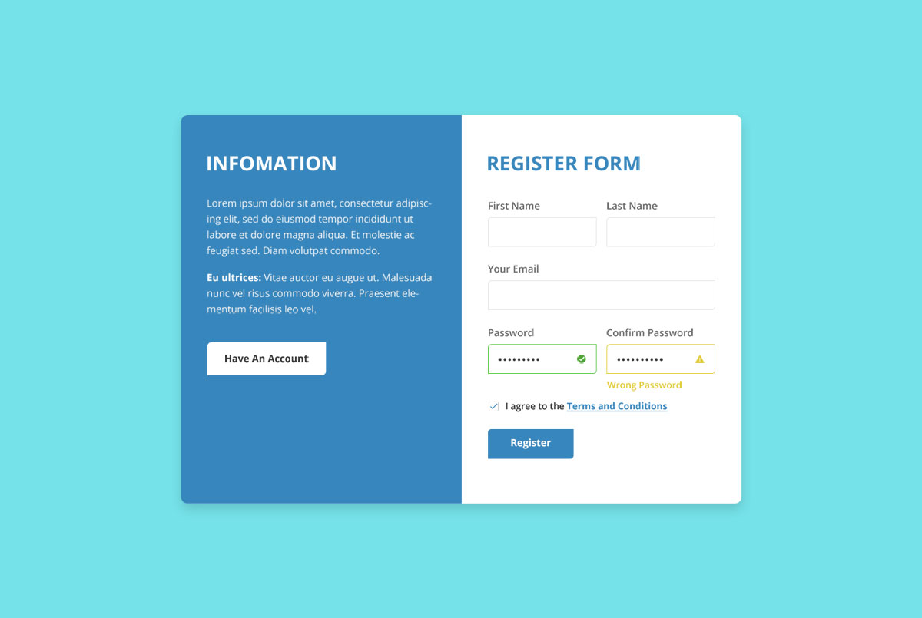

Sample Agenda for the meeting organized by Project Manager
Hi All,

Hope you all are doing great!

I am blocking your calendar for an important meeting on our new project discussion with our client and all other team members.

Agenda of this meeting:
- Project members introduction and Interview by the client
- Gathering all the vital details about the project.
- Discussion about the deadline for SRS Document, Design Specification Document.
- Discussion about the deadline of the project completion.
- Panel Discussion regarding the project.
- Closing Remarks
I request everyone to attend the meeting on time.

Regards
Mohammed Ezaz Ahamed (2389627)
Project Manager, Cognizant

Sample details collected by the client during the interview conducted with the project members. These details will be sent to the Lead client by the client.
SKILLS AND EXPERIENCES OF PROJECT TEAM MEMBERS
PROJECT: EVENT MANAGEMENT SYSTEM
MOHAMMED EZAZ AHAMED (2389627) (PROJECT MANAGER)
- Skills
- Leadership,
- Communication,
- Time management,
- Negotiating,
- Team management,
- Critical thinking
- Experience:
- Worked on many projects as a project manager and successfully completed them on time with user satisfaction
- Managed a small group of peers on certain parts of the project.
- Managed the whole team, communicating with the customers, teammates and other people in the organization.

TAMMANA SRI GAYATHRI (2389628) (TEAM LEAD)
- Skills:
- Communication and interpersonal skills
- Ability to negotiate and resolve conflicts
- Building commitment within the team
- Experience:
- Inspiring positive communication within them so that they can work together toward achieving goals.
- Organizing a study group
- Spotting a problem at work and finding a solution
MANITEJA MEELA (2389613) (DEVELOPER)
- Skills
- Knowledge of coding languages for project handling.
- Good knowledge of operating systems
- Has knowledge of databases which are required to manage data
- Familiar with IDEs and source control
- Experience
- Worked on similar projects
- Created functional software tools
MANTHRI SIDDIRAMULU (2389622) (DEVELOPER)
- Skills
- Have knowledge in coding language in order to handle the project
- Have database knowledge which is required in managing data
- Have worked with the ide's prior so has knowledge in source control
- Experience
- Worked on similar project previously
- Has experience in creating functional and well-designed software tools

JAJAPURAM ANJALI (2389561) (FRONTEND DEVELOPER)
- Skills
- Problem solving ability in analyzing the task given
- Good technical strength in java script and react
- Familiar with state management libraries (e.g., Redux)
- Experiences
- Worked on many other projects with User interface designing
- Developed responsive web applications.

Sumanth Veludandi (2389630) (FRONTEND DEVELOPER)
- Skills
- Problem solving ability in analyzing the task given
- Good technical strength in java script and react
- Familiar with state management libraries (e.g., Redux)
- Experiences
- Worked on many other projects with User interface designing
- Developed responsive web applications.
MAMINDLA DARSHINI ANANYA (2389592) (FRONTEND DEVELOPER)
- Skills
- Problem solving ability in analyzing the task given
- Good technical strength in java script and react
- Familiar with state management libraries (e.g., Redux)
- Experiences
- Worked on many other projects with User interface designing
- Developed responsive web applications.

SEELAM JEEVAN (2389583) (FRONTEND DEVELOPER)
- Skills
- Proficient in Selenium for automated testing
- Knowledge of test frameworks (e.g., TestNG, JUnit)
- Experience with scripting languages (e.g., Python, Java)

- Experiences
- Developed automated test scripts
- Executed and maintained test cases.

Sample Minutes of Meetings sent by the Project Manager to all the invitees
Subject: Minutes of Meetings-Event Management System (EMS) project

Hi all,

I hope you all are doing well.

Thanks so much for taking the time to meet the EMS project discussion today. The purpose of this meeting was to get to know the stakeholders who will be working for this project and to get on the same page about the specifications and requirements and discuss the project.

As a quick recap, we discussed:
- Roles of the team members and their skills and experience.
- Tasks that need to be done.
- Clarification of the problem.
We concluded that:
- We'll be drafting the SRS document for our client to review it for approval.
- We'll try our best to complete this task in the given time.
Our next steps for successful completion will be:
- Our Team lead Tammana Sri Gayathri will assign tasks to developers.
- Developers will complete their assigned task in the given time.
- I will be taking updates from the team lead about the project.

We plan to meet again in 2 days, and I wish the team members all the best.

Regards
Ezaz Ahamed,
Project Manager

Sample email sent by the Project Manager to the Client after the Call.

Hi Mahaboob,

Hope you are doing well.

Thank you for sharing the problem statement.
I will have a discussion with my team and will share with you the detailed requirements along with the product requirement document by today.
Regards
Ezaz Ahamed
Project Manager, Cognizant
M: 8688778391

Sample 1 - Email sent by the Project Manager to the Team Lead after the Call.

Subject: Gear up - Project EVENT MANAGEMENT SYSTEM
Hi Madhav,

Hope you are doing well.

As we are aware of the discussion held in the EVENT MANAGEMENT SYSTEM project meeting with the client and the team members, I am looking forward to an outstanding performance by our team in this project. I have a firm belief that our team will perform.

Here I am also attaching the specifications/requirements that I received from our client for a better understanding of the project.

Feel free to reach out to me, and all the best from my end.

Regards
Ezaz Ahamed
Project Manager, Cognizant
M: 8688778391

Sample 2 - Email sent by the Project Manager to the Team Lead after the Call

Dear Team Lead,

I hope you are doing well.

Over the last meeting, we convened with the whole team and the client. We have gone through the project requirements of the client, and we shall commit straight away with the initial works.

The requirements of client are:

- Websites should be dynamic and user friendly.
- It should have a pleasant color combination.
- It should contain a login page and a registration page.
- Main module should deal with the accounts of the company and should show the investment, loss, profit and all the expenses.
- Websites should be quick, responsive and of high capability.

With the requirements clearly defined, we are now ready to officially start the project. We shall start by preparing the SRS and Design documents and get it approved by the client. I respectfully request you to instruct your developers to prepare the documents as quickly as possible.

Regards
Ezaz Ahamed
Project Manager, Cognizant
M: 8688778391

Sample email sent by the Team Lead to the Developers

Hi Team,
I hope everything is going well at your end.

From the discussion by our team with the client in the client meeting held yesterday, you have to work on the SRS document and the Design document for the "Event Management System" project as per the client requirements.

In our team:
- Mani will work on the SRS document
- Jeevan will work on the Design document for this project.
I request both of you to share the above-mentioned documents with me by 16th April 2025.

All the Best!

Regards,
Tammana Sri Gayathri
Team Lead, Cognizant

Sample email sent by the Developer to the Team Lead after completing the SRS document

Hi Tammana Sri Gayathri,

Hope you are doing well.

I want to inform you that the task assigned to make a design document for the EVENT MANAGEMENT SYSTEM project has been completed and I have attached the design document with the mail.

However, if you have any queries regarding the document, you can contact me anytime. So we can start our work for the next phase at the earliest.

Thank you for your sincere support throughout the project discussion, without which it could not have been completed within this limited time.

ManiTeja Meela
Project Developer
EVENT MANAGEMENT SYSTEM project
Cognizant

Sample email sent by the Team Lead to the Project Manager after receiving the SRS, Design document, and Database schema from the developers

Hi Ezaz,

I have attached the SRS, design document and database schema for your reference.

I hope this document meets the client's requirements. Please, let me know if anything is missing or needs to be changed.

After you have reviewed the documents, we can discuss further steps.

I am looking forward to hearing back from you.

Regards,
Tammana Sri Gayathri
Team Lead
Cognizant
M: 9691187069

Sample email sent by Project Manager to Client after receiving the SRS, Design document, and Database schema from the Team Lead

Hi Mahaboob,

As we discussed with you, we prepared the SRS and Database design as per your requirements. Please review and provide us with feedback.

We are open to hearing your thoughts on this. After your approval, we will move forward with the project.

Regards
Ezaz Ahamed
Project Manager, Cognizant
M: 8688778391

Sample email sent by Client to Project manager approving the documents.

Hi Ezaz,

This email is to inform you that we have approved the latest SRS and database design of EMS project sent to us on 16th April 2025.

Please get started with the further steps of developing this project.

Regards,
B MAHABOOB BASHA
Mahaboob.basha@cognizant.com
M +91 8688778391

Sample email sent by Project manager to Team Lead after approval of the client.

Hi Gayathri,

Hope you are doing well.

As we discussed with the client about the project, and after sending the SRS and database design, our client is happy with your work. Now I am looking forward to an outstanding performance in development also.

I am also attaching the SRS and database design which have been approved by the client.

Feel free to contact me if you have any queries, and all the best from my end for development.

Regards
Ezaz Ahamed
Project Manager, Cognizant
M: 8688778391

Minutes of Meeting

Meeting Date and Time | 15th April 2025, 4:30 PM | Minutes Drafted Date | 09-Jun-2022
Meeting Organizer | Daithiya Sudan | Meeting Title | Project Simulation Meeting

Attendees
- Tammana Sri Gayathri - Team Leader
- Mahaboob Basha - Client
- Mohammed Ezaz Ahamed - Project Manager
- Maniteja Meela - Backend Developer
- Mantri Siddiramulu - Backend Developer
- Mamindla Darshini - Frontend Developer
- Jajapuram Anjali - Frontend Developer
- Sumanth Veludandi - Frontend Developer
- Seelam Jeevan - Tester
- Kathi Ramya - Tester

Brief Description / Agenda
- Gathering all the important details about the project.
- Understanding the needs and requirements of the client.
- Discussion about the deadline for MOM, SRS Document, and Design Specification Document.
- Discussion about the deadline of the project completion.
- Panel Discussion regarding the project.
- Closing Remarks

Summary of the discussion
No | Items Discussed
1 | In the meeting, Mahaboob discussed the needs and requirements of the new project and interviewed the developers on their skill sets for the project.
2 | There was also a discussion about the deadline for MOM, SRS Document, and Design Specification Document.
3 | The technical team organized a demonstration of the features of the website. Everyone in the meeting agreed that we should proceed with the design.
4 | After the design was agreed upon, the date for the project completion was discussed and fixed.
5 | In a conclusion, Gayathri discussed the summary of the meeting.

Meeting Conclusion
The meeting concluded with everyone on the team recommending proceeding with the requirements of the client

Action Items
No | Action Item | Owner | Due Date
1 | Provide the software requirement system | Mahaboob basha | 15th April 25
2 | Start development of the new site design. | Gayathri & Team | 16th April 25
3 | Review performance issues and recommend remediation. | Mahaboob Basha | 17th April 25

Software Requirements Specification (SRS)

1. Introduction
1.1 Purpose
The purpose of this document is to provide a comprehensive overview of the requirements for the Event Management System. This system will facilitate the organization, management, and participation in events, providing functionalities for users and administrators.
1.2 Scope
The Event Management System will include modules for User Management, Event Management, Ticket Management, Notification Management, and Feedback Management. The system will not include any payment functionalities.
1.3 Definitions, Acronyms, and Abbreviations
- EMS: Event Management System
- Admin: Administrator
- User: Registered participant or attendee
1.4 References
- Project documentation
- Industry standards for event management systems
2. Overall Description
2.1 Product Perspective
The EMS will be a standalone web application accessible via standard web browsers. It will provide a user-friendly interface for both users and administrators.
2.2 Product Functions
- User registration and profile management
- Event creation and management
- Ticket booking and management
- Notification sending and management
- Feedback collection and management
2.3 User Classes and Characteristics
- Admin: Responsible for managing events, users, and system settings.
- User: Can register, view events, book tickets, receive notifications, and provide feedback.
2.4 Operating Environment
The system will operate in a web environment, compatible with major browsers such as Chrome, Firefox, and Edge.
2.5 Design and Implementation Constraints
- The system must be responsive and accessible on various devices.
- Security measures must be implemented to protect user data.
2.6 Assumptions and Dependencies
- Users will have access to the internet and a web browser.
- The system will rely on a backend server for data storage and processing.
3. Specific Requirements
3.1 User Module
3.1.1 User Registration
- Users must be able to register with their email and password.
- Users must receive a confirmation email upon successful registration.
3.1.2 User Profile Management
- Users must be able to update their profile information.
- Users must be able to view their event participation history.
3.2 Event Module
3.2.1 Event Creation
- Admins must be able to create new events with details such as name, date, location, and description.
- Admins must be able to edit or delete events.
3.2.2 Event Viewing
- Users must be able to view a list of upcoming events.
- Users must be able to search for events by name, date, or location.
3.3 Ticket Module
3.3.1 Ticket Booking
- Users must be able to book tickets for events.
- Users must receive a confirmation email upon successful booking.
3.3.2 Ticket Management
- Admins must be able to view and manage ticket bookings.
- Admins must be able to generate reports on ticket sales.
3.4 Notification Module
3.4.1 Notification Sending
- Admins must be able to send notifications to users about upcoming events.
- Notifications must be sent via email and displayed within the system.
3.4.2 Notification Management
- Users must be able to view a history of notifications received.
- Users must be able to opt-in or opt-out of email notifications.
3.5 Feedback Module
3.5.1 Feedback Collection
- Users must be able to provide feedback on events they attended.
- Feedback must include ratings and comments.
3.5.2 Feedback Management
- Admins must be able to view and manage user feedback.
- Admins must be able to generate reports on feedback received.
4. System Features
4.1 Security
- The system must implement user authentication and authorization.
- Data must be encrypted during transmission and storage.
4.2 Usability
- The system must have an intuitive and user-friendly interface.
- The system must be accessible to users with disabilities.
4.3 Performance
- The system must be able to handle a large number of concurrent users.
- The system must have fast response times for user actions.
4.4 Reliability
- The system must have high availability and minimal downtime.
- The system must implement backup and recovery procedures.
5. Appendices
5.1 Glossary
- Event: An organized occasion such as a conference, seminar, or concert.
- Ticket: A document confirming a user's participation in an event.
- Notification: A message sent to users to inform them about events or updates.
- Feedback: User-provided ratings and comments on events.

Thank you!

